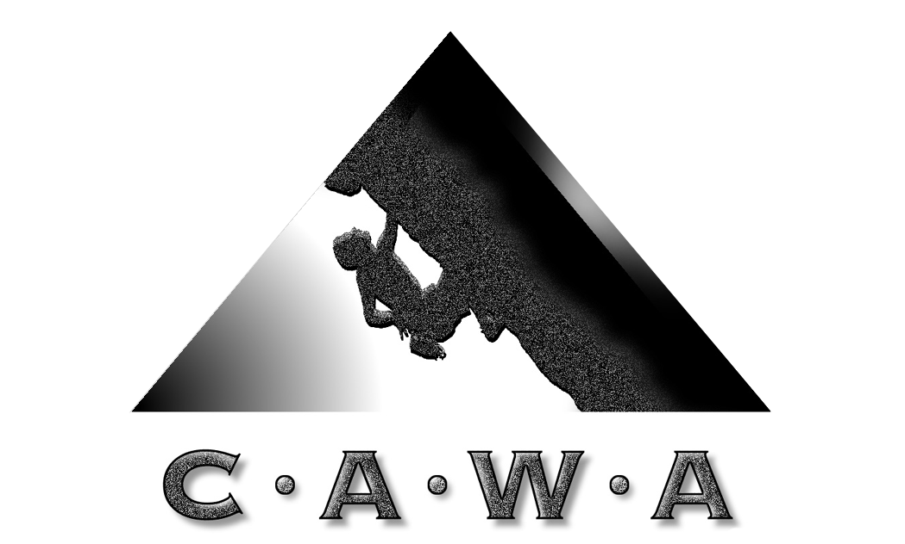
Climbers Association of Western Australia
PO Box 7125, Cloisters Square
Western Australia, 6850
Email : cawa@climberswa.asn.au
Web : www.climberswa.asn.au
FB : www.facebook.com/climberswa

CAWA POP-UP CLIMBING TRIP # 1
WHERE : Willyabrup
WHEN : 19th and 20th October 2013
DETAIL :
- Weekend of climbing at Willyabrup Cliffs.
- Multitude of routes from # 10 and up. Mixed trad & sports routes. Full trad rack, Sports Rack
- Open to CAWA members.
- Bring all your own gear
- Camping at Gracetown Caravan & Camping Park nearby
- No need to register, just turn up.
THIS IS NOT A GUIDED, INSTRUCTIONAL OR COORDINATED TRIP. CLIMB AT YOUR OWN RISK.
REFERENCES & MAPS :
See : Margaret River Rock, Author Shane Richardson for routes and descriptions
Mud Map :
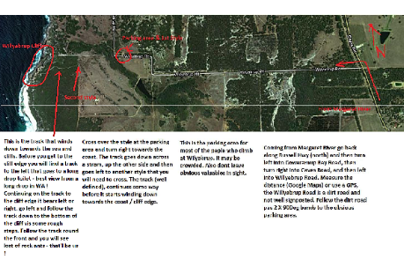
Accommodation :
We usually stay at Gracetown Camping and Caravan Park on the corner of Gracetown Road and Caves Road. Contact http://www.gracetowncaravanpark.com.au/ Ask if there is a CAWA group site allocated.
CONTACT :
Tony Brebner tonyb@climberswa.asn.au or Mark Kleinman markk@climberswa.asn.au

